**Lab Exercise 7- Install Minikube on Linux (Ubuntu /MacOS/Windows)**

**Install Minikube on Linux (Ubuntu)**

sudo apt install -y docker.io # Ubuntu

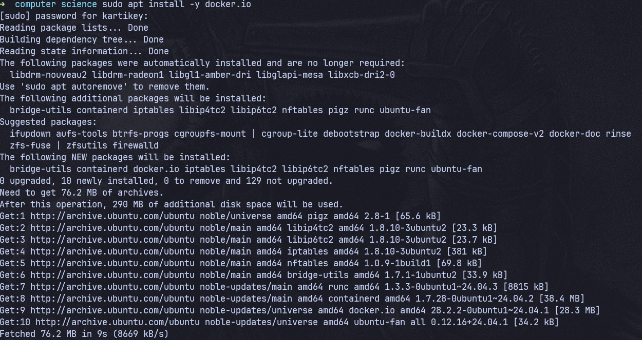

sudo systemctl start docker

sudo systemctl enable docker

sudo usermod -aG docker $USER

newgrp docker

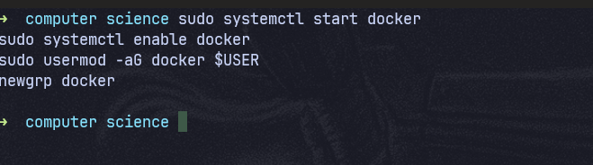

**Step 2: Install kubectl**

curl -LO <https://storage>.googleapis.com/kubernetes-release/release/$(curl -s <https://storage>.googleapis.com/kubernetes-release/release/stable.txt)/bin/linux/amd64/kubectl

chmod +x kubectl

sudo mv kubectl /usr/local/bin/

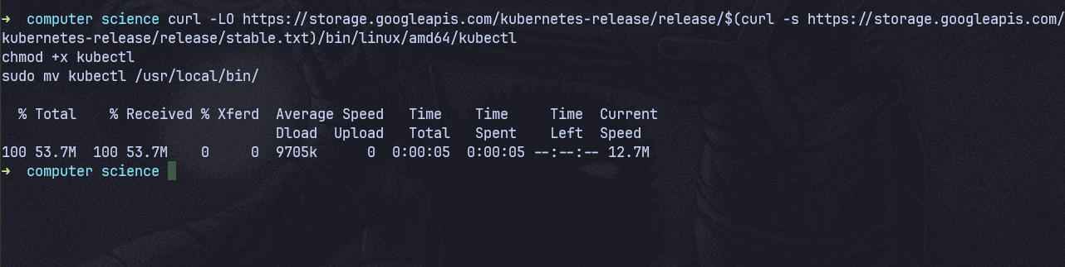

Verify:

kubectl version –client

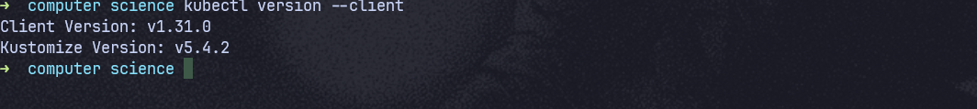

**Step 3: Install Minikube**

curl -LO <https://storage>.googleapis.com/minikube/releases/latest/minikube-linux-amd64

chmod +x minikube-linux-amd64

sudo mv minikube-linux-amd64 /usr/local/bin/minikube

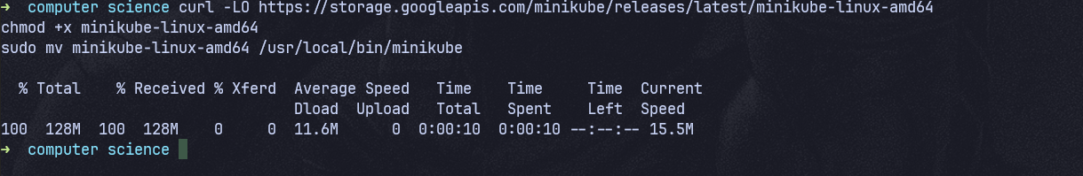

Verify:

minikube version

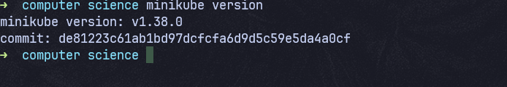

**Step 4: Start Minikube**

minikube start --driver=docker

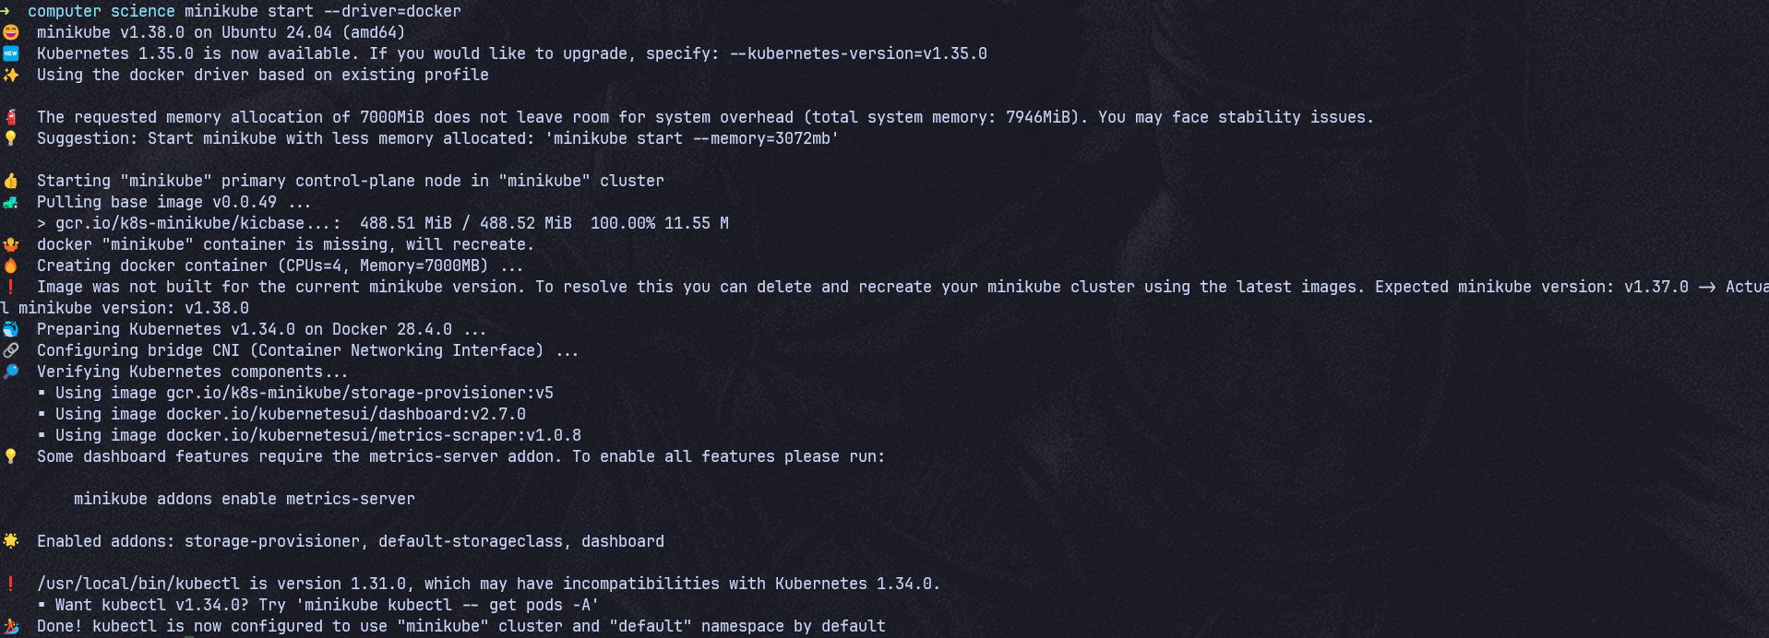

Check status:

minikube status

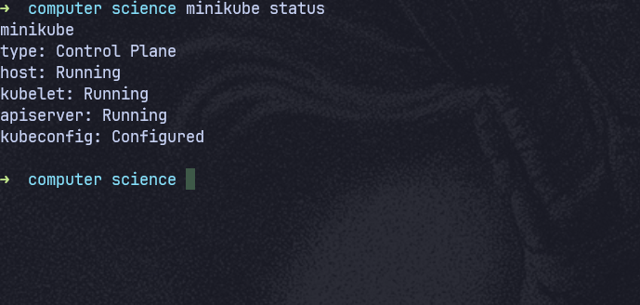

**Install Minikube on Windows**

**Prerequisites**

* Docker Desktop installed
* Enable WSL2

**Install Minikube**

choco install minikube -y

OR download exe:

https://github.com/kubernetes/minikube/releases/latest

Start:

minikube start

**Install Minikube on macOS**

brew install minikube

brew install kubectl

Start:

minikube start

**Verify Kubernetes Cluster**

kubectl get nodes

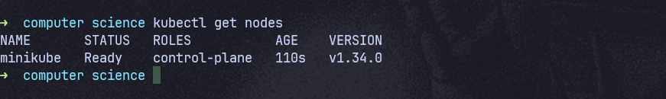

Expected output:

NAME STATUS ROLES AGE VERSION

minikube Ready control-plane xx v1.xx

**Useful Minikube Commands (Lab Ready)**

| **Command** | **Purpose** |
| --- | --- |
| minikube dashboard | Open K8s UI |
| minikube stop | Stop cluster |
| minikube delete | Delete cluster |
| minikube ssh | Access node |
| kubectl get pods -A | View all pods |

Minikube dashboard

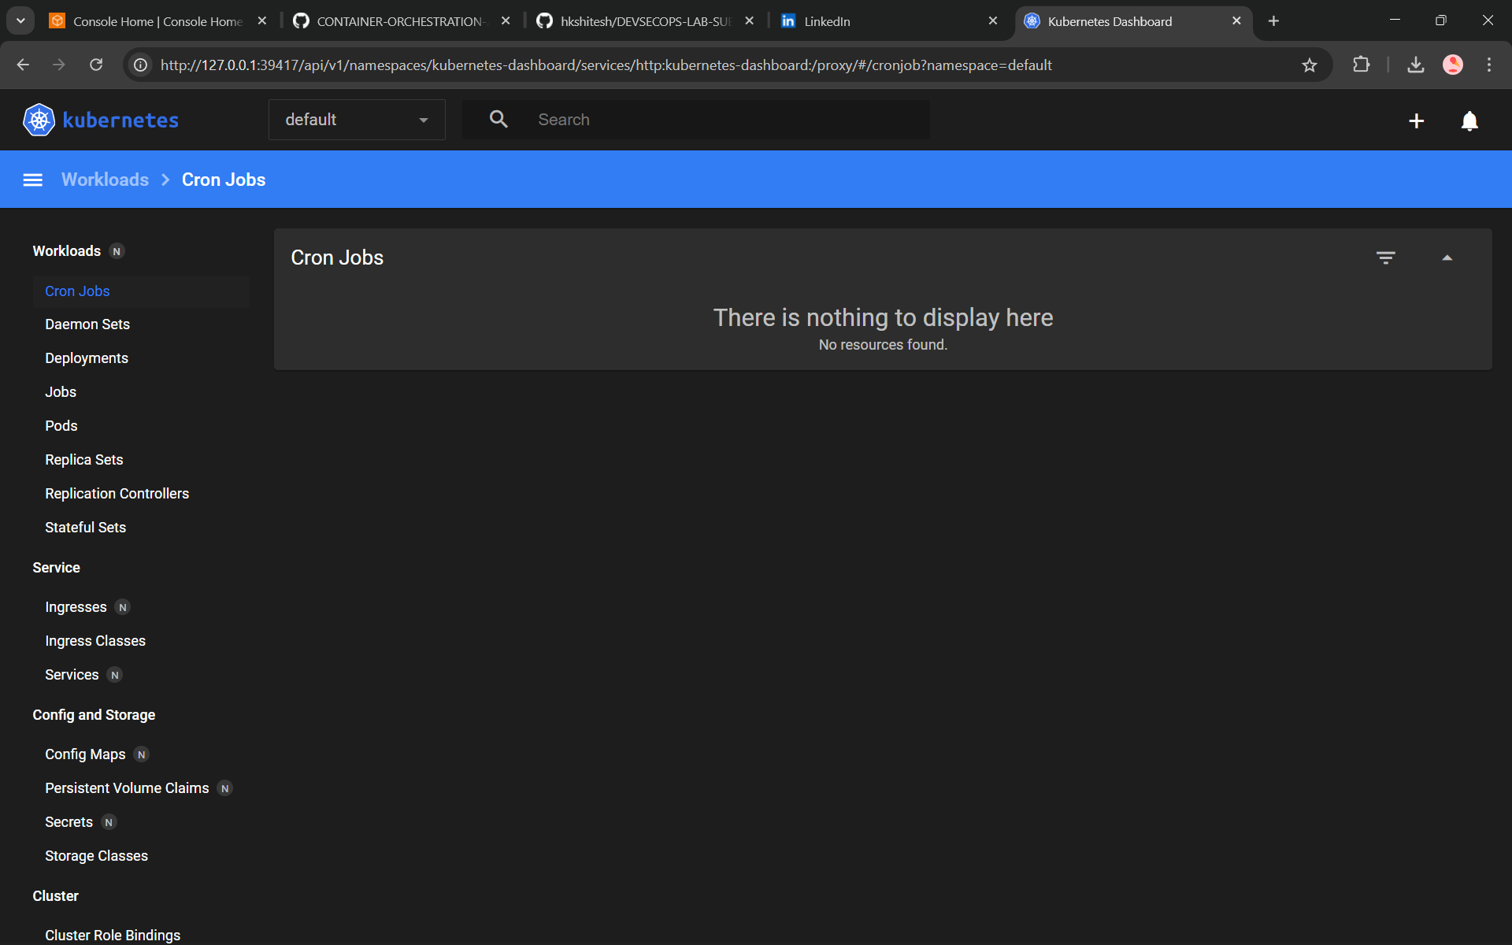

Minikube Stop

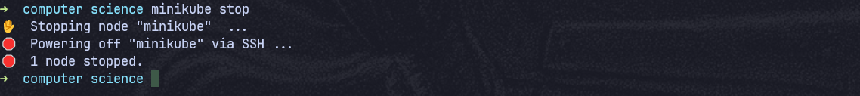

Minikube ssh

